Add to bag documentation:

1. Open project in IntelliJ IDE.
2. Refresh the maven project
   1. Click on the maven icon on the right hand side  
      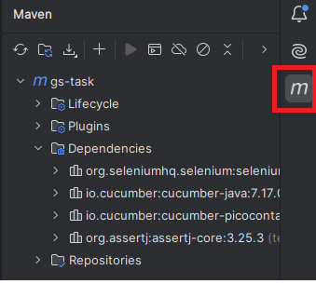
   2. Click on the refresh button:  
      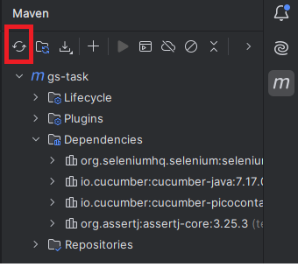
   3. Wait of the project repository to be recompiled.
3. Download chrome driver from the link: [**https://googlechromelabs.github.io/chrome-for-testing/**](https://googlechromelabs.github.io/chrome-for-testing/)
   1. Verify the chrome driver version with your google chrome version.  
      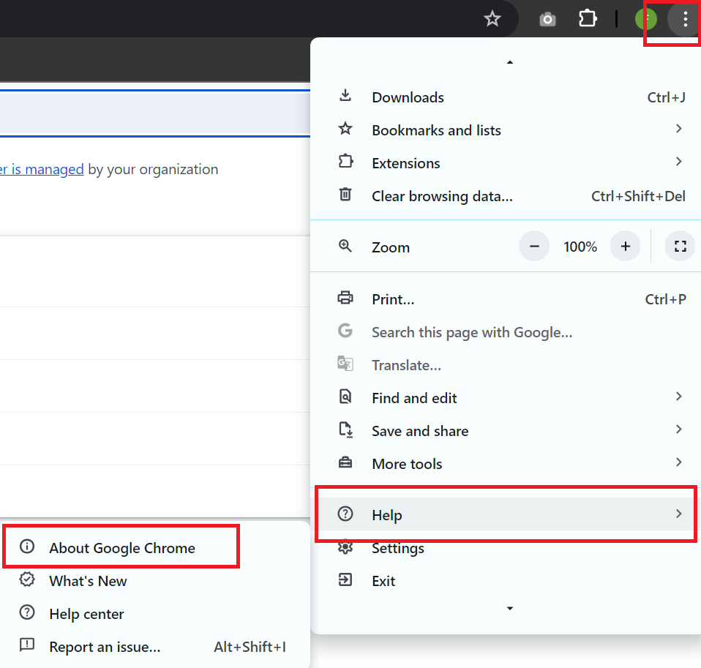
   2. Copy the downloaded chrome driver into resource folder in root  
      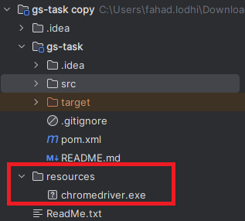
4. Change the chrome path in src/test/java/stepdefs/hooks/Hooks.java
   1. on line no. 19, change the path with your respective path  
      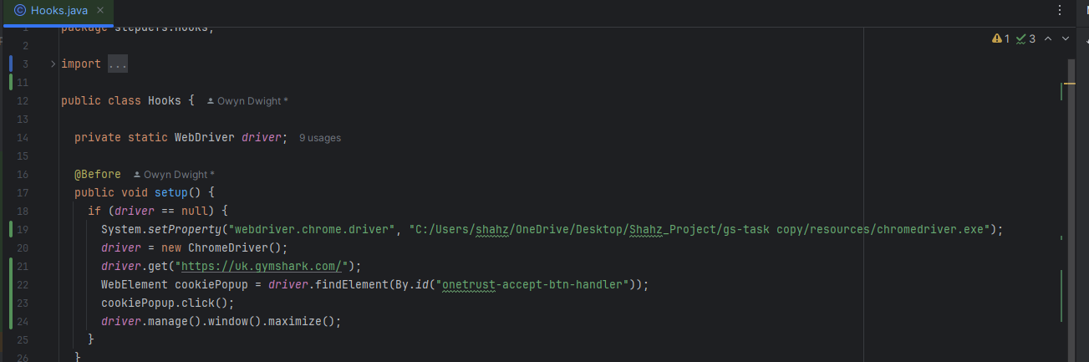
5. Goto to feature file and run the test 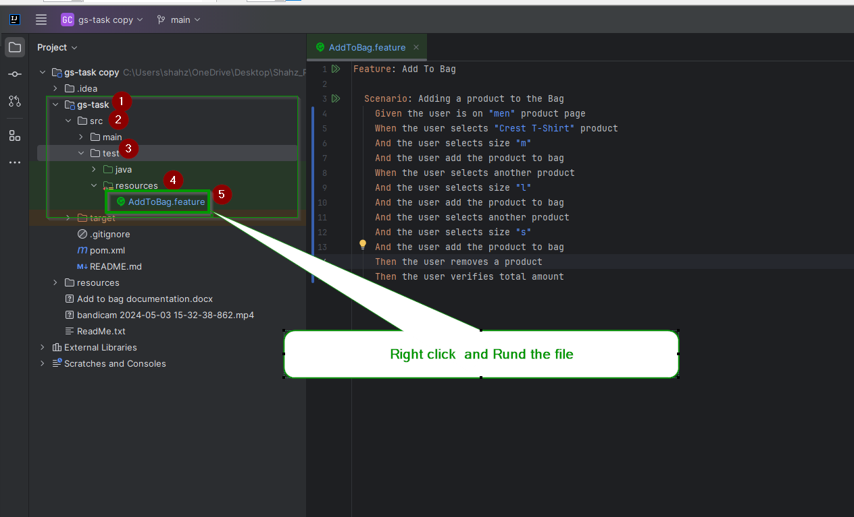 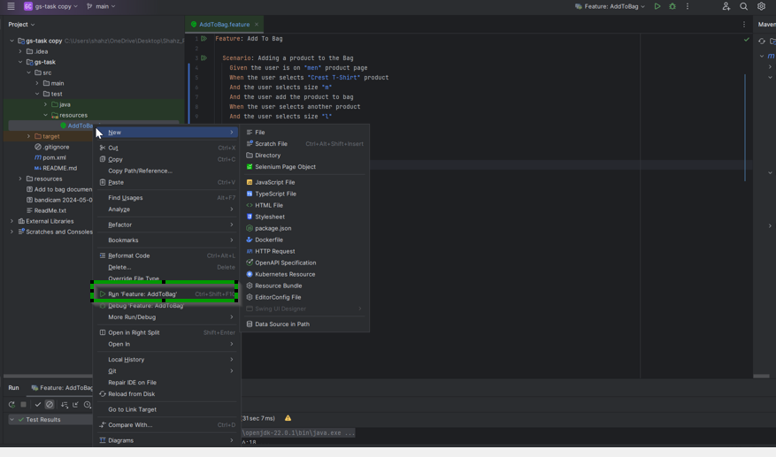 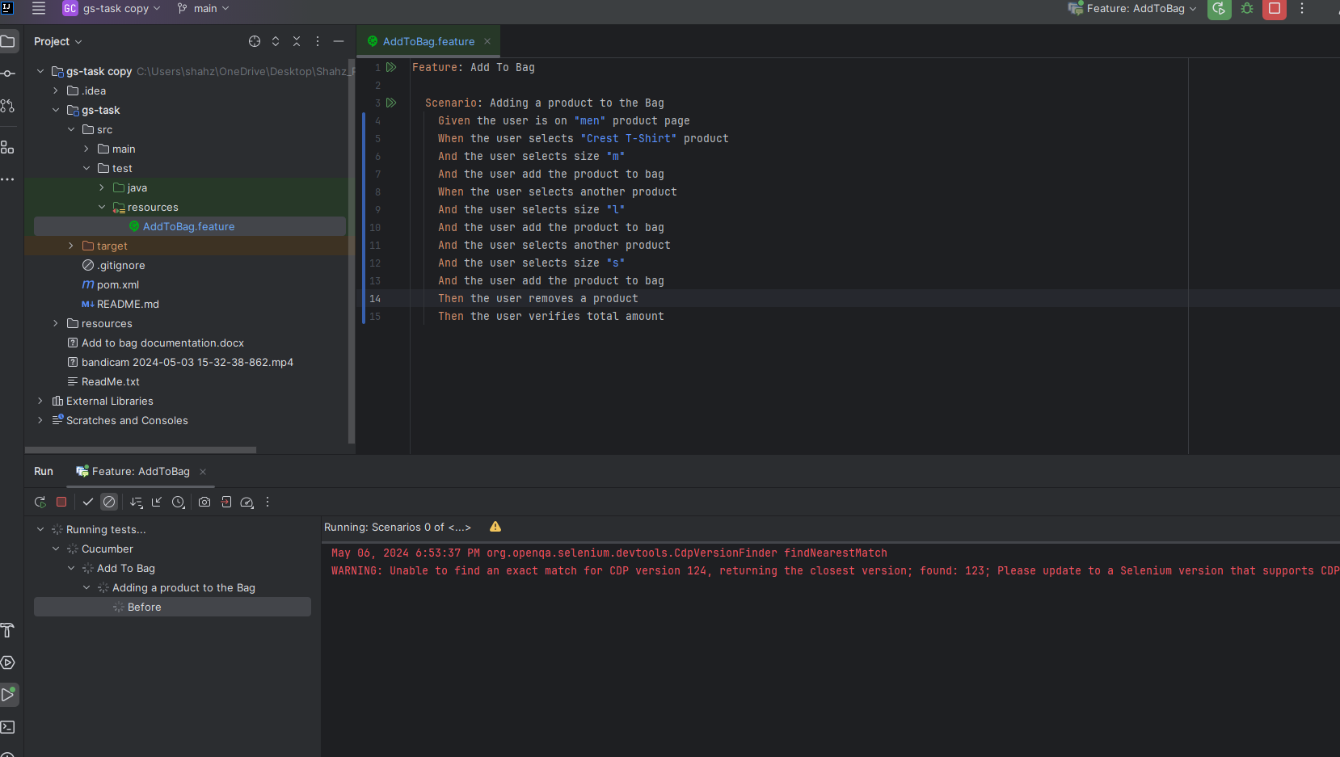 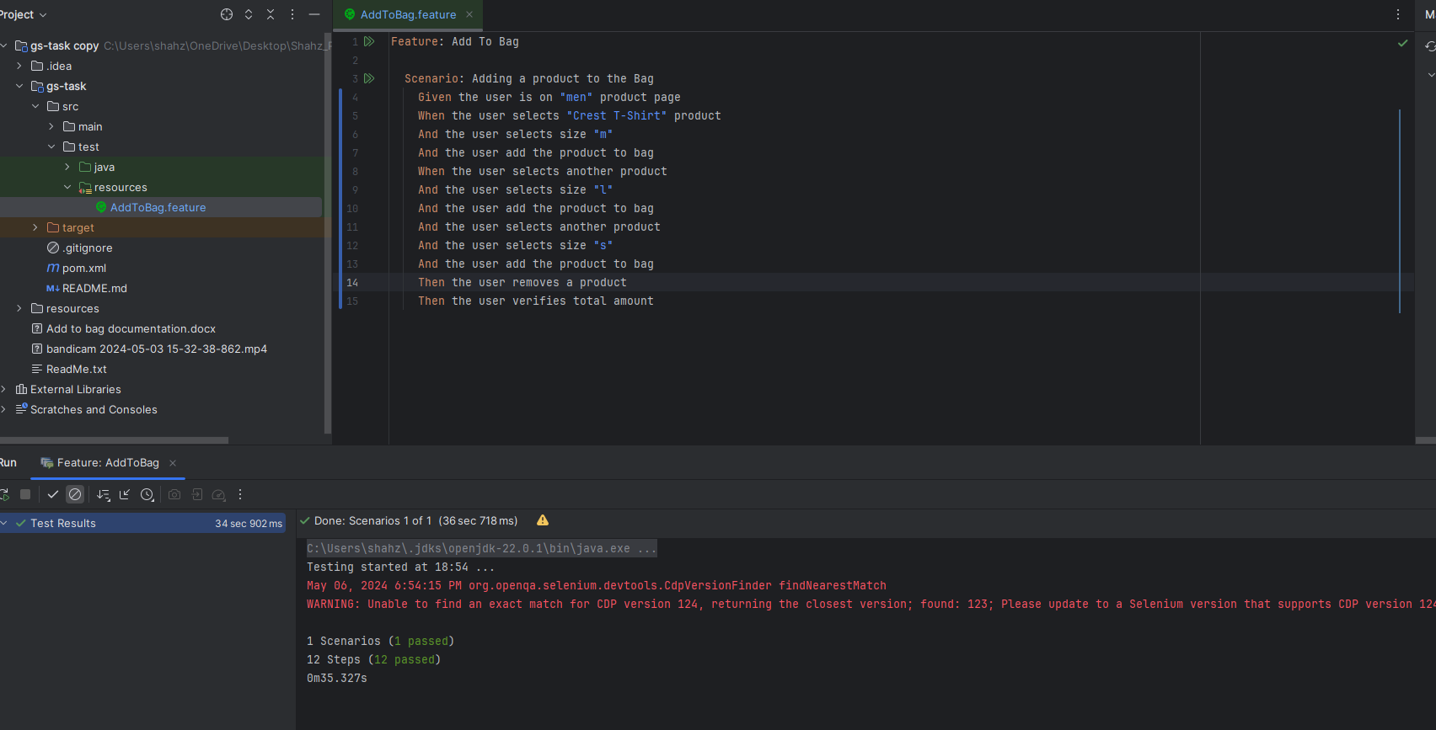
6. Java JDK 22 download link: <https://www.oracle.com/java/technologies/downloads/#jdk22-windows>
7. IntelliJ download link: https://www.jetbrains.com/idea/download/?section=windows
8. Chrome driver download: https://googlechromelabs.github.io/chrome-for-testing/
9. Maven repository: https://mvnrepository.com/artifact/org.seleniumhq.selenium/selenium-chrome-driver